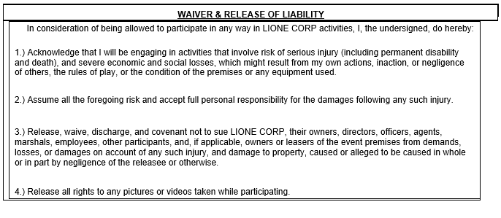
I have read and understand the WAIVER & RELEASE OF LIABILITY terms and conditions ___________ (initial)
FULL NAME (Please Print) : ________________________________________________________
Date of Birth : _________________________________
E-Mail Address: _______________________________________________
This waiver and release of liability will be in effect 01/01/2022, and will remain valid until 12/31/2022.
By signing this waiver. I acknowledge and agree to the above release of liability.
I also agree to abide by all LIONE Corp policies, rules, and code of conduct. Failure to comply may result in disciplinary action at the discretion of the LIONE Corp board of directors, up to and including expulsion from current and/or future LIONE Corp events.

